**User Research:**

Our research focus was to understand the payment journey for a normal user as well as users accustomed to using a mobile wallet. We also tried to identify current hurdles and successes of existing mobile wallet implementations. We conducted two focus groups and started an online discussion in the Apple as well as Android subreddits to gauge what the user expected from a mobile wallet. This user research helped us generalize and find our target users.

**Focus Groups and Interviews:**

Our first focus group consisted of **7 graduates** pursuing either Master’s or PHDs in various disciplines who have never to rarely used mobile wallet whereas our second focus group comprised of **5 expert users**. They all possessed a vehicle and primarily used their vehicle for going to class and coming back. We also supplemented the focus group finding with one-on-one interviews with undergraduates on the campus. The questions asked during personal interviews were derived from the focus group questionnaire:

|  |  |
| --- | --- |
| **Questions for Novice Users** | **Questions for Expert Users** |
| Do you own a smartphone? About how many different apps do you use daily on your phone? | Which mobile wallet do you use? Any specific reason for preferring a particular mobile wallet? |
| Do you prefer carrying cash or credit/debit cards? How many credit cards/debit cards/loyalty cards you normally carry? | How often do you use your mobile wallet? What do you use it for? |
| Have you used any type of mobile wallet?  If Yes,   1. Which mobile wallet application do you normally use? 2. How many transactions on a daily/monthly basis do you perform? 3. What do you use your mobile wallet for? 4. How is your experience using your mobile wallet to pay for things? 5. How long have you been using the mobile wallet?   If No,   1. Please describe your experience using credit cards/debit cards and is there anything that can be done to improve your experience | Can you give us a walkthrough of a typical payment experience using your mobile wallet?  In your opinion, what are the best things about using a mobile wallet and what are the things that can be improved upon?  What capabilities would you build into the mobile wallet? Where would like to use it? |

**Potential user needs that we uncovered are as follows:**

1. More efficient tracking of rewards and loyalty cards;

2. Information about expenses or a way to track spending

3. Use the mobile wallet to pay bus fare, at gas pumps, restaurants (with tips), barber and in the university food court

4. Automatically redeem loyalty cards points while checking out

5. Pay friends/family members easily with one tap

6. Filling credit cards details while shopping online automatically

7. Set up recurring transfers easily

**Brainstorming:**

To sort and prioritize our brainstorming results, analyze findings from the user research, and identify and group user functions as part of the design we developed affinity diagrams. Affinity diagramming helped us to find themes and structures in the data. After creating the affinity diagram, we walked the data reading through the data thread to find loopholes and design ideas. We grouped our ideas into four main categories which are as follows:

1. Payment use cases
2. Credit/debit/loyalty card management,
3. Expense tracking,
4. Banking related information
5. Peer to peer payment.

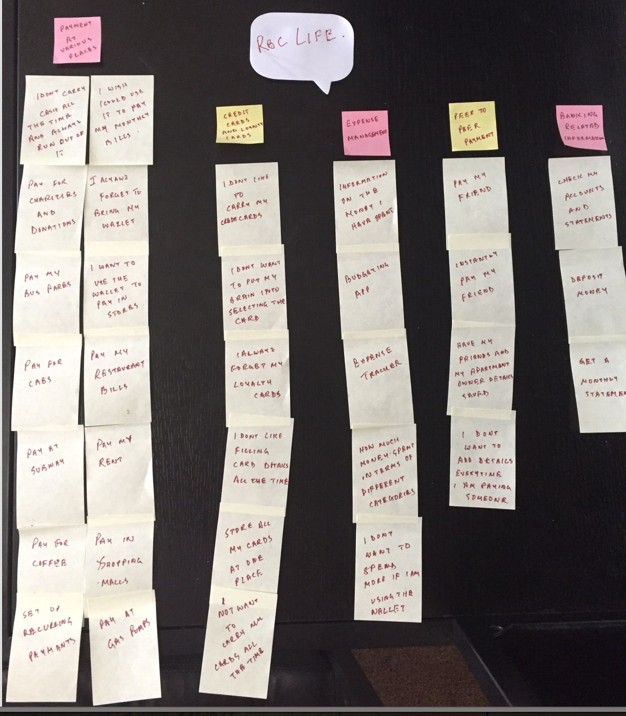

Figure : Final Affinity Diagram

The categories represent solutions to the most relevant problems faced by users. After brainstorming over the top points, we came to the conclusion that these solutions will ensure that all user needs are been addressed and fulfilled. These solutions include single view organization of credit cards/debit cards, auto-redeeming loyalty card points, managing expenses, one tap payment of bus fares, ability to set up recurring transfers, pay friends through the mobile wallet (peer to peer payment), and eliminate card details entry while shopping online.

**Ranking User Needs:**

We ranked user needs and focused on needs which were ranked higher; we also included medium priority user requirements as they seem to fall under the categories which we specified during the affinity diagramming stage. These ranking drove our final design:

